PRESS RELEASE

COMMUNICATIONS AND MEDIA TEAM OF THE 2023 ASEAN SUMMIT

No.48/SP/TKM-ASEAN2023/ENG/5/2023

Indonesia Continues to Strengthen Protection of Indonesian Citizens

West Manggarai, 8 May 2023 – President Joko “Jokowi” Widodo emphasized the government's commitment to continue to strengthen the protection of Indonesian citizens. In this regard, the government has recently succeeded in evacuating Indonesian citizens from Sudan.

"In the midst of various difficulties, the government has succeeded in evacuating Indonesian citizens from Sudan. As of today, the number of Indonesian citizens who have been evacuated is 969 people. 936 have returned home and 33 are in safe locations outside Sudan," said President Jokowi in a press conference at the Meruorah Hotel, West Manggarai Regency, East Nusa Tenggara Province, Monday, 8 May 2023.

Jokowi also asserted that the government would maintain this commitment. "We will continue to improve and strengthen the protection of Indonesian citizens," the President added.

Previously, Minister of Foreign Affairs Retno Marsudi also explained the evacuation of Indonesian citizens from Sudan. The effort has been very carefully designed, while the evacuation was executed through a quite but fast operation.

"We always choose a quiet operation because it’s concerning the safety and security of the Indonesian citizens to be evacuated given the very dynamic, very fluid local situations that can threaten the safety of Indonesian citizens," said Retno. (Presidential Secretariat/TR/Elvira/WS/PPR)

***

For more information, please contact:

Director General of Public Information and Communications of the Ministry of Communications and Informatics - Usman Kansong (0816785320)

Get other information at http://asean2023.id, https://infopublik.id/kategori/asean-2023, and https://indonesia.go.id/kategori/ragam-asean-2023

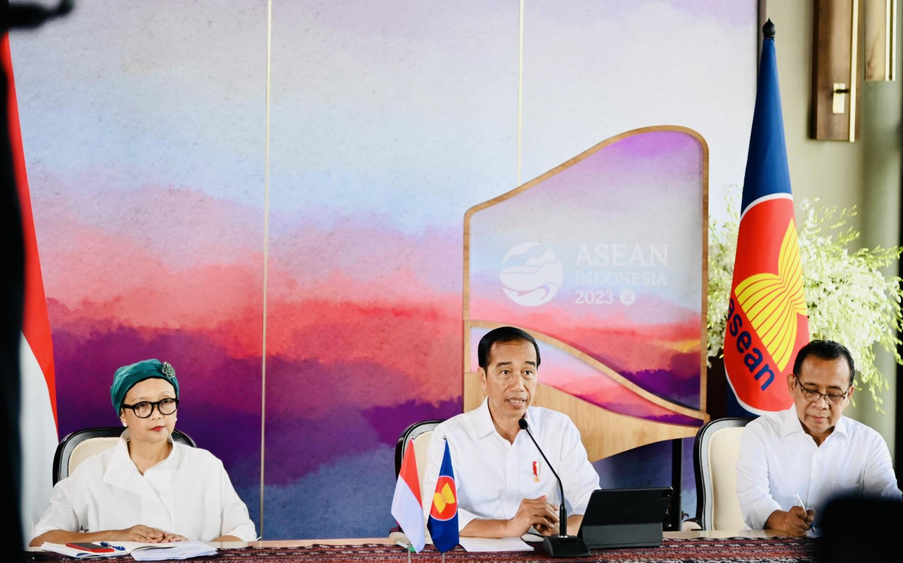

President Joko Widodo in a press conference at the Meruorah Hotel, West Manggarai Regency, East Nusa Tenggara Province, Monday, 8 May 2023. The government continues to strengthen the protection of Indonesian citizens.

